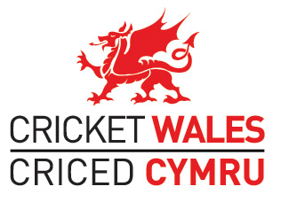

Resolution to be put by the Cricket Wales Board to the 2017 Cricket Wales AGM

Following decisions by an independent Nominations Panel the Cricket Wales Board resolves that the 2017 Cricket Wales AGM ratifies the following individuals to serve as Directors of Cricket Wales for the term lengths specified:

Tariq Awan Recreational Game Director Three years
Dafydd Huw Morgan Independent Director Three years
Jeffrey Roger Bird Glamorgan Cricket Director One year
Hugh Morris Glamorgan Cricket Director One year

